- UNGA draft resolution on 'veto power use'
Topic: International Relations
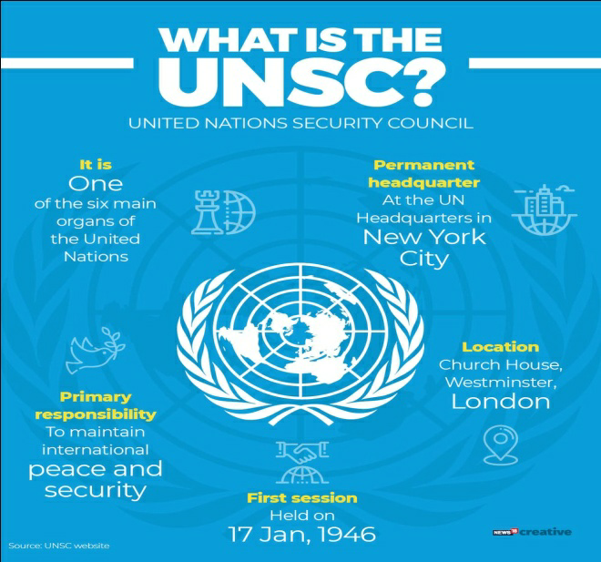
In News: India has expressed concerns over UNGA draft resolution on 'veto power use'.
More on the Topic:
- The United Nations General Assembly (UNGA) passed resolution which requires the Assembly to meet every time a veto is used in the UN Security Council.
- The resolution was adopted by consensus and it became Effective immediately.
- The United Nations Security Council veto power is the power of the five permanent members of the UN Security Council (China, France, Russia, the United Kingdom, and the United States) to veto any "substantive" resolution.
- They also happen to be the nuclear-weapon states (NWS) under the terms of the Treaty on the Non-Proliferation of Nuclear Weapons (NPT).
Why India has expressed Concerns?
- India said though it supports any initiative that genuinely furthers the objective of achieving meaningful and comprehensive reform, the current resolution “demands much more serious, in-depth, and inclusive deliberation than was allowed by the movers of this text”.
- India expressed support to calls made by African countries to abolish the veto power as a matter of principle.
- The main problem with the current system is the capturing of governing capacity of international security relations by the elite class of countries.
Need of the Hour:
- There is need to expand permanent membership of UNSC.
- The absence in the UNSC of the globally important countries – India, Germany, Brazil and South Africa - is a matter of concern.
- The resolution recently passed is not an answer to these problems.
- The elite decision-making structure does not suit the current global security needs.
- All five permanent UNSC members have used the veto over the last 75 years to “achieve their respective political ends.
- There is a longstanding acknowledgement of the need to expand the UNSC, both its permanent and non-permanent membership, to make it representative of the contemporary world, and not the world of its founding in 1945.
Source: Indian Express
- Violence, Deaths By Naxals Reduced Significantly
Topic: Internal Security
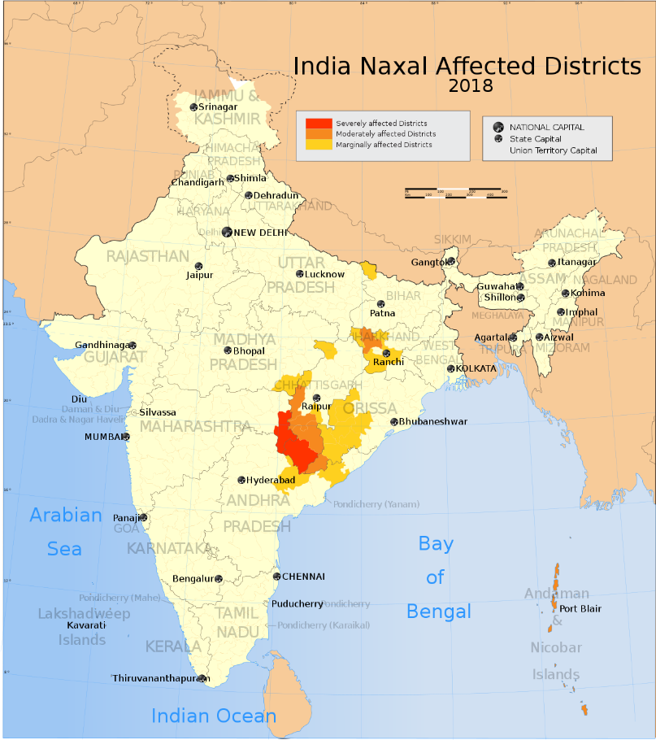
In News: According to the annual report of the Ministry of Home Affairs for 2020-21, the Naxal violence has been reduced significantly.
More on the Topic:
- Following are the excerpts from the report:
- Naxal violence was reported from 226 police stations in 53 districts spread across nine states in 2020 as compared to 328 police stations in 76 districts spread over 10 states in 2013.
- The last six years have seen a significant decline in Left Wing Extremism (LWE) violence as well as the geographical spread of the LWE.
- The declining trend which started in 2011 continues in 2020 as well.
- The casualties to security forces declined by 17 per cent (52 to 43).
Reasons Behind the Achievement:
- The developmental outreach by the central government has seen an increasingly large number of LWE cadres shunning the path of violence and returning to the mainstream.
- The overall improvement in the LWE scenario can be attributed to greater presence and increased capacity of the security forces across the LWE affected states, better operational strategy and better monitoring of development schemes in affected areas.
About Left Wing Extremism:
- The Naxalite–Maoist insurgency, officially referred to as the Left Wing Extremism (LWE), is an ongoing conflict between Maoist groups known as Naxalites or Naxals (a group of communists supportive of Maoist political sentiment and ideology) and the Indian government.
- Reasons behind left Wing Extremism: Inequitable development (example: The failure of land reforms especially land redistribution after independence, Socio-economic inequities, unemployment, despair about the future etc.), Displacement of people: (Eviction from lands traditionally used by tribals), Discrimination against tribals: Poor implementation of laws prohibiting transfer of tribal land to non-tribals in the Fifth Schedule areas.
Way Ahead:
- The law enforcement agencies should not approach left wing extremism in a purely law and order point of view.
- Improving the conditions of the poor and the tribal clearly need to be speeded up to eliminate LWE altogether.
- Development of road and rail infrastructure will not only enhance economic growth and development but will also help in countering Maoist propaganda.
- Surrendering ex Maoists should be provided with alternative livelihood opportunities as well as incentives.
- Through a holistic approach focusing on development and security related interventions, the LWE problem can be successfully tackled.
Source: Indian Express
3. Canine Distemper Virus (CDV) vaccine
Topic: Environment and Ecology
In News: The Gujarat Biotechnology Research Centre has developed and completed the first trials of the Canine Distemper Virus (CDV) vaccine on guinea pigs and rats.
More on the Topic:
- The vaccine is being prepared for the Asiatic lion (Panthera leo persica) population in Gir National Park.
- In 2018 around 27 lions had succumbed to the disease.
- The vaccine would go through three trials before being administered on lions.
- Canine distemper is caused by the paramyxovirus virus. It spreads through body fluids like infected urine, blood and saliva.
- The virus attacks the respiratory, gastrointestinal and nervous systems of puppies and dogs and can be transmitted to lions, tigers, leopards and other wild cats as well as seals.
- The virus is also found in wild foxes, wolves, coyotes, raccoons, skunks, mink and ferrets. Its symptoms include dullness, lacrimation, cough, diarrhea and seizures.
Source: Indian Express
______________________________________________________________________________

4. PLI schemes for white goods
Topic: Economy
In News: Under the scheme for white goods, eligible investors in air-conditioners, LED lights and such components will be granted incentive.
More on the Topic:
- In order to boost domestic manufacturing and cut down on import bills, the union government in March 2020 introduced a PLI scheme that aims to give companies incentives on incremental sales from products manufactured in domestic units.
- Apart from inviting foreign companies to set shop in India, the scheme also aims to encourage local companies to set up or expand existing manufacturing units.
- The schemes have been specifically designed to attract investments in sectors of core competency and cutting edge technology; ensure efficiency and bring economies of size and scale in the manufacturing sector and make Indian manufacturers globally competitive so that they can integrate with global value chains.
- The PLI schemes are being implemented by the concerned Ministries/ Departments.
- There are targeted promotion activities being taken up by concerned Ministries/ Departments for identification of potential global and domestic investors.
- All the approved sectors identified under PLI Schemes follow the broad framework of new and emerging technologies where India can leapfrog, overall economic gain accruing to the economy and export potential of the sectors.
- These sectors were recommended by NITI Aayog after detailed deliberations with concerned Ministries/ Departments followed by approval of the Union Cabinet.
- Any new sector for PLI will require fresh approval of the Cabinet.
Source: Indian Express
_____________________________________________________________________________

5. Shri Narayana Guru
Topic: Personalities in News
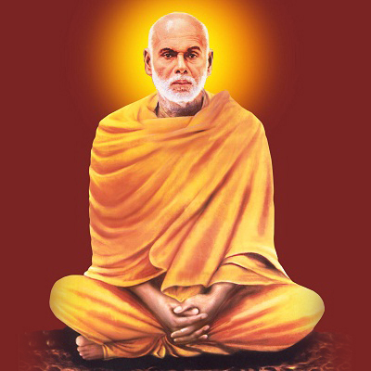
In News: Prime The Prime Minister participated in the inaugural ceremony of year-long joint celebrations of the 90th anniversary of Sivagiri Pilgrimage and Golden Jubilee of Brahma Vidhyalaya. Both are initiated by Shri Narayana guru.
More on the Topic:
- Guru was a philosopher, spiritual leader and social reformer in India.
- He led a reform movement against the injustice in the caste-ridden society of Kerala in order to promote spiritual enlightenment and social equality.
- The Guru was born into an Ezhava family, in an era when people from backward communities like the Ezhavas faced social injustice in the caste-ridden Kerala society.
- Shri Narayana Dharma Paripalana Yogam (also known as SNDP Yogam) is an Indian spiritual organization that was formally founded by Padmanabhan Palpu in 1903, with the guidance of Shri Narayana Guru.
- Vaikom Satyagraha (1924–25) was a social protest in erstwhile Travancore against untouchability and caste discrimination in Hindu society of Kerala.
Source: Business Standard
____________________________________________________________________________________

6. Trem Stage-IV emission norms
Topic: Environment and Ecology
In News: A formal notification extending the deadline for implementing the Trem Stage-IV emission norms for the farm sector would be issues shortly.
More on the Topic:
- Bharat Stage or BS Emission Standards are government-instituted emission standards that all motor vehicles have to comply with if they are to be sold and driven in India.
- Currently, all new vehicles sold and registered in India should be compliant with the BS-VI iteration of emission standards.
- The Ministry has notified amendment to Central Motar Vehicle Rules 1989 on 30th September, 2020 deferring the applicability date for implementing the next stage of emission norms for tractors and Construction Equipment Vehicles.
- There was also change in the nomenclature of emission norms from Bharat Stage (CEV/TREM) IV and Bharat Stage (CEV/TREM)V to TREM Stage-IV and TREM Stage-V for agriculture al tractors and other equipment.
Reason for change in date of implementation:
- Following stricter emission norms for farm equipment that conform to Euro Stage IV norms would mean that the prices of these equipment would have to be increased by 10-20% for the extra specifications.
- At a time, inflation is already high, raising the cost of equipment may result in squeezing farmers’ income.
Source: Hindu
______________________________________________________________________________

7. Meghalaya Enterprise Architecture (MeghEA)
Topic: e Governance
In News: The Meghalaya Enterprise Architecture (MeghEA), has won a coveted UN Award World Summit on the Information Society Forum (WSIS) Prizes, 2022.
More on the Topic:
- The project aims to improve service delivery and governance for the people using the power of Digital technologies.
- Enterprise Architecture (EA) is the process by which organizations standardize and organize IT (Information Technology) infrastructure to align with business goals.
- The initiative is spread across 6 pillars i.e. Governance, Human Resources, Entrepreneurship, Primary Sector, Infrastructure and Environment, and envision to make Meghalaya a high income state by 2030.
Source: Hindu
______________________________________________________________________________

