- GST compensation
Topic: Economy
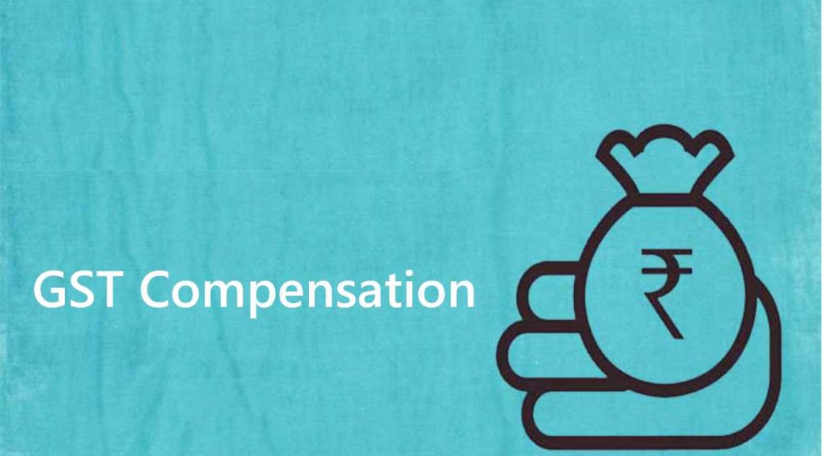
In News: The Centre has released the entire amount of GST compensation payable to states up to May 31, 2022.
More on the Topic:
- The goods and services tax (GST) was introduced in the country from July 1, 2017 and states were assured of compensation for loss of any revenue arising on account of implementation of the tax reform measure according to the provisions of the GST (Compensation to States) Act, 2017 for a period of five years.
- For providing compensation to states, a cess is being levied on certain goods and the amount collected is being credited to the Compensation Fund. Example: Cess on sin goods like tobacco.
- Compensation to states is being paid out of the Compensation Fund from July 1, 2017.
About Cess:
- Cess is a tax levied for a specific purpose and ought to be used for the same only.
- The process of cess levying occurs after Parliament has authorised its creation through an enabling legislation that specifies the purpose for which the funds are being raised.
- Article 270 of the Constitution allows cess to be excluded from the purview of the divisible pool of taxes that the Union government must share with the States.
Source: Indian Express
- Government e Market Place
Topic: Government Schemes
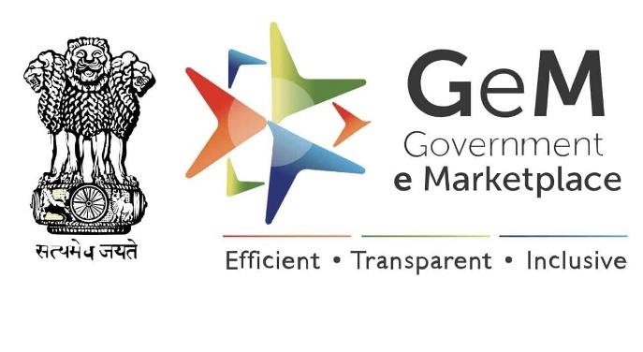
In News: The Union Cabinet has expanded the scope of the public procurement portal Government e-Marketplace (GeM) to allow cooperative societies to register as buyers.
More on the Topic:
- The decision is expected to help cooperatives in getting competitive prices through an open and transparent process.
- It will enhance the Ease of Doing Business for cooperatives while providing a larger Buyer base to the GeM registered sellers also.
About Government e-Marketplace (GeM):
- Government e-Marketplace (GeM) is a one stop portal to facilitate online procurement of common use Goods & Services required by various Government Departments / Organizations / PSUs.
- GeM aims to enhance transparency, efficiency and speed in public procurement.
- It provides the tools of e-bidding, reverse e-auction and demand aggregation to facilitate the government users achieve the best value for their money.
- The procurement of goods and services by Ministries and the Central Public Sector Enterprises (CPSEs) is mandatory for goods and services available on GeM.
- Ministry of Commerce and Industry is the nodal ministry of e Market Place.
Source: Indian Express
3. Leadership Group for Industry Transition (LeadIT)
Topic: International Affairs
In News: Union environment minister participated in a high-level dialogue under the Leadership Group for Industry Transition (LeadIT).
More on the Topic:
- LeadIT gathers countries and companies committed to action to achieve the Paris Agreement climate goal.
- It was launched by the governments of Sweden and India at the UN Climate Action Summit in September 2019 and is supported by the World Economic Forum (WEF).
- It is intended as a Voluntary initiative for promoting low-carbon transition through active participation of private sector companies.
- Especially in the sectors like Iron & Steel, Aluminium, Cement and Concrete, petrochemicals, fertilisers, bricks, heavy-duty transport.
- Currently, the Group has a membership of 16 countries and 19 companies including Dalmia Cement, Mahindra Group and SpiceJet from India.
- Secretariat is hosted by Stockholm Environment Institute (SEI), Sweden.
Significance of the Group:
- Industry sectors together contribute about 30% of the total CO2 emissions, and thus, efforts to drive low carbon development pathways in industry sector are critical for achieving the goals of the Paris Agreement.
Source: Indian Express
______________________________________________________________________________
4. Radio-frequency identification (RFID) technology
Topic: Science and Technology
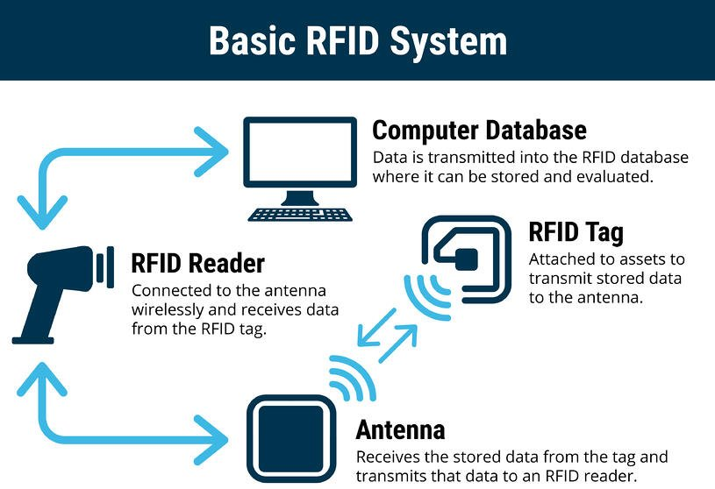
In News: Baggage tags equipped with radio-frequency identification (RFID) will soon be available at Delhi’s Indira Gandhi International Airport, marking a first of its kind for the country.
More on the Topic:
- Radio-frequency identification (RFID) is a technology that uses radio waves to automatically identify various tagged objects.
- Radio Frequency Identification (RFID) is a wireless tracking method that uses tags and readers to track objects.
- Transponder, receiver, and transmitter are the three components of an RFID system.
- The RFID reader continually sends radio waves of a specific frequency in RFID system.
- If the object to which the RFID tag is attached is within the range of the radio waves, it provides feedback to the RFID reader, which then identifies the object based on the feedback.
About the different kinds of RFID?
- Passive tags, semi-passive tags, and active tags are the three types of RFID tags that are commercially available.
- There is no power supply for passive tags. They acquire their power from the readers’ incoming radio waves.
- Semi-passive tags comprise an internal circuit with a power source, but rely on the radio waves received from the reader to transmit the response.
- The Low Frequency, High Frequency, and Ultra-High Frequency bands are used by RFID systems.
What is a barcode?
- A barcode is a printed series of parallel bars or lines of varying width used for entering data into a computer system.
- The bars are black on a white background and vary in width and quantity depending on the application.
- The bars represent the binary digits zero and one, which represent the digits zero to nine processed by a digital computer.
- These barcodes are scanned using special optical scanners known as barcode readers.
- The numbers that make up a barcode are also printed at the bottom. One of the most well-known examples of a barcode is the QR code.
Radio-frequency identification (RFID) technology Vs barcodes
- RFID uses radio waves to communicate data from RFID chips to readers that do not require line of sight in order to obtain the data, whereas barcodes use light to read the black-and-white pattern printed on the sticky tag.
- An RFID tag can communicate with a powered reader even when the tag is not powered.
Source: Indian Express
_____________________________________________________________________________
5. National Assessment and Accreditation Council (NAAC)
Topic: Governance
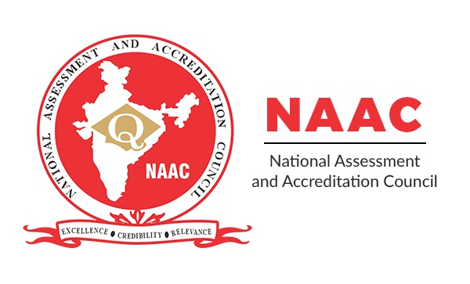
In News: The National Assessment and Accreditation Council (NAAC) has proposed that college-level examination papers be redesigned so that at least 10 per cent of marks are given based on the evaluation of “higher-order cognition” among students to encourage the development of critical thinking.
More on the Topic:
- The National Assessment and Accreditation Council is a government organization in India that assesses and accredits Higher Education Institutions.
- It is an autonomous body funded by the University Grants Commission and headquartered in Bangalore.
- The NAAC has been set up to facilitate the volunteering institutions to assess their performance vis-a-vis set parameters through introspection and a process that provides space for participation of the institution.
- NAAC gives institutions grades ranging from A++ to C.
Source: Business Standard
____________________________________________________________________________________
6. Valmiki Tiger Reserve
Topic: Environment and Ecology
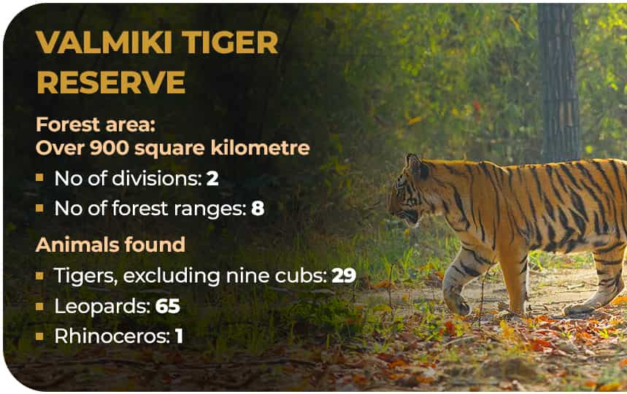
In News: The forest department of Bihar has established an elephant rescue centre at Bihar’s Valmiki Tiger Reserve (VTR) to rehabilitate stray, abandoned and injured elephants.
More on the Topic:
- VTR is spread over 899 square kilometres in West Champaran district, with Nepal to its north and Uttar Pradesh to its west.
- It represents one of the last patches of forests having a unique combination of the terai-bhabar vegetation.
- The forests of Bihar don’t have any elephants right now.
- Herds of elephants stray into Bihar either from Chitwan and Parsa wildlife sanctuary of Nepal or from forest of Jharkhand.
- A study and survey have been conducted by a team of forest officials and wildlife experts on the availability of food, water and natural habitat for the rescued elephants in the VTR.
Source: Hindu
______________________________________________________________________________

7. Damini - Lightning Alert App
Topic: Science and Technology
In News: Damini App will be made in to local languages.
More on the Topic:
- Damini Lightning Alert application is for giving warning to the user about the lightning on the basis of user location.
- The app monitors the lightning occurrence all over India and alerts the user of lightning near them by a GPS notification under 20 km and 40 km.
- Further, the Damini app also triggers warning about lightning strikes three hours in advance which can help reduce losses to life and property.
- User can view Lightning which occurred in last 5 min, 10 min & 15 min on the map.
Source: Hindu
______________________________________________________________________________

