- Production-Linked Incentive (Pli) Scheme
Topic: Economy
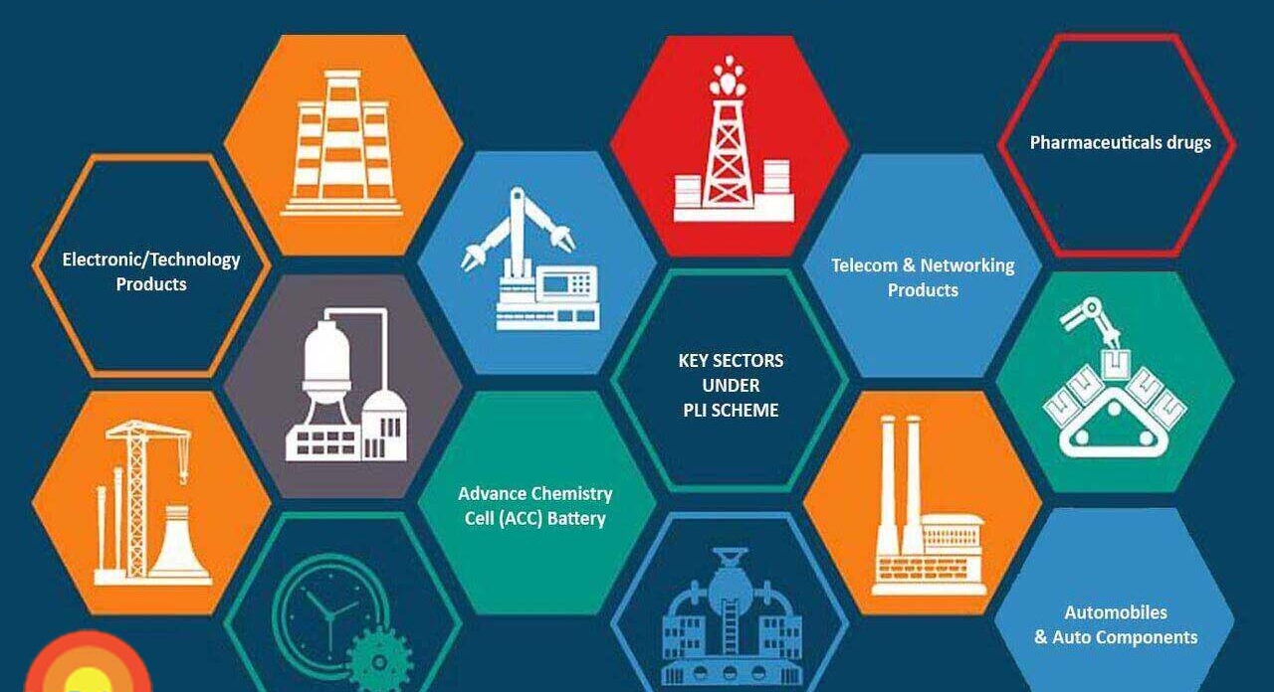
In News: As part of the Atmanirbhar Bharat initiative, in the first-ever disbursement under PLI scheme was approved recently by an empowered committee headed by NITI Aayog CEO.
More on the Topic:
- Production linked incentive (PLI) schemes are a cornerstone of the government’s push for accomplishing the vision of Atmanirbhar Bharat.
- It intends to make India a manufacturing hub.
- The strategy behind scheme is to offer financial incentive to boost electronics manufacturing and attract large scale investments.
Objective of the Scheme:
- To make domestic manufacturing globally competitive and to create global champions in manufacturing.
- To provide support towards the existing domestic companies to expand their manufacturing units.
- To ensure that more employment opportunities are provided to Indian citizens in the manufacturing sector.
Implementation of the Scheme:
- The government has rolled out the scheme with an outlay of about ₹2 lakh crore for as many as 14 sectors, including automobiles and auto components, white goods, pharma, textiles, advance chemistry cell and specialty steel.
- The scheme shall extend an incentive of 4% to 6% on incremental sales (over base year) of goods manufactured in India and covered under target segments, to eligible companies, for a period of five (5) years with financial year (FY) 2019-20 considered as the base year for calculation of incentives.
- The Scheme will be implemented through a Nodal Agency which shall act as a Project Management Agency (PMA) and be responsible for providing secretarial, managerial and implementation support and carrying out other responsibilities as assigned by MeitY from time to time.
Incremental Sale?
- So, basically Incremental sales are a concept wherein a company manages to sell more products as compared to its estimates. But to ramp up production in order to sell more products companies usually need to go for self- funding.
- In the PLI Scheme however, the Government will provide subsidies/ incentives on this “Incremental Sale” of goods manufactured in domestic units i.e within India.
Source: Indian Express
_____________________________________________________________________________________
2. Green Hydrogen
Topic: Science and Technology
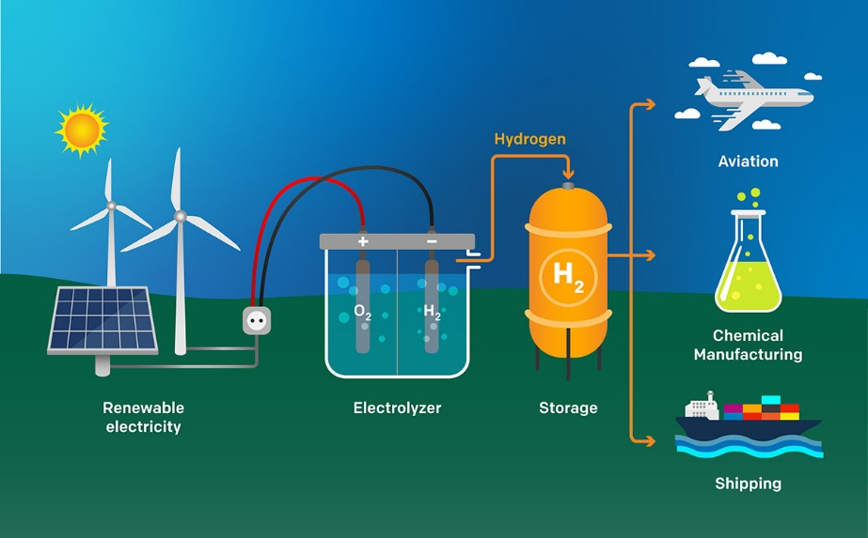
In News: According to a new study, Green hydrogen would likely supply less than 1 per cent of final energy globally by 2035.
More on the Topic:
- Green Hydrogen Production technology is based on the generation of hydrogen, a universal, light and highly reactive fuel through a chemical process known as electrolysis.
- This method uses an electrical current to separate the hydrogen from the oxygen in water.
- If this electricity is obtained from renewable sources we will, therefore, produce energy without emitting carbon dioxide into the atmosphere.
Barriers in Green Energy Production:
- High cost: energy from renewable sources, which are key to generating green hydrogen through electrolysis, is more expensive to generate, which in turn makes hydrogen more expensive to obtain.
- High energy consumption: the production of hydrogen in general and green hydrogen in particular requires more energy than other fuels.
- Safety issues: hydrogen is a highly volatile and flammable element and extensive safety measures are therefore required to prevent leakage and explosions.
- Demand Gap: There is a lack of industrial demand for hydrogen (especially green hydrogen).
Significance of Green Hydrogen:
- 100 % sustainable: green hydrogen does not emit polluting gases either during combustion or during production.
- Storable: hydrogen is easy to store, which allows it to be used subsequently for other purposes and at times other than immediately after its production.
- Versatile: green hydrogen can be transformed into electricity or synthetic gas and used for commercial, industrial or mobility purposes.
Way Ahead:
- The study has recommended the following to improve Green Hydrogen production.
- Implementing strong policies is the need of the hour. Fostering green hydrogen growth will require strong dedication, coordination and funding along the entire value chain.
- Carbon pricing should always form the basis of climate policy.
- Carbon pricing is a policy tool that puts a tax on producers of greenhouse gas emissions. This will improve green energy production.
- Accelerating the roll-out of crucial zero-carbon technologies like electric mobility and heat pumps. These technologies make more efficient use of scarce renewable electricity
Source: Hindu
____________________________________________________________________________________

3. Dara Shikoh
Topic: Personalities in News
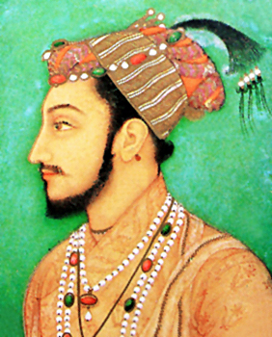
In News: Vice president of India has released Arabic Version of “Majma Ul-Bahrain” of Dara Shikoh.
More on the Topic:
- Majma-ul-Bahrain (which means ‘Confluence of Two Oceans’) throws invaluable light on the similarities between religions and helped bring stronger unity among the people of India.
- In this book he has listed one by one, all the commonalities between Hinduism (Vedanta) and Islam (Sufism) and came to the conclusion that the difference between Islam and Hinduism is only verbal.
- He translated the Upanishads and other important sources of Hindu religion and spirituality from Sanskrit to Persian.
About Dara Shikoh:
- Dara Shikoh was the eldest son and heir-apparent of the Mughal emperor Shah Jahan.
- A great patron of the arts, he was also more inclined towards philosophy and mysticism rather than military pursuits.
- In the war of succession which ensued after Shah Jahan's illness in 1657, Dara was defeated by his younger brother Prince Muhiuddin (later, the Emperor Aurangzeb).
- He was executed in 1659 on Aurangzeb's orders in a bitter struggle for the imperial throne.
Source: Hindu

4.Self Help Groups
Topic: Social Justice
In News: The Ministry of Rural Development (MoRD) is conducting a 15-day national campaign to accelerate the process of mobilisation of left-out rural poor women across 34 states and Union Territories into women’s Self Help Groups (SHGs).
More on the Topic:
- The campaign is under Deendayal Antyodaya Yojana-National Rural Livelihoods Mission (DAY-NRLM).
- National Rural Livelihoods Mission (NRLM) was launched by the MoRD in 2011 as a restructured version of Swarna Jayanti Gram Swarozgar Yojna (SGSY).
- The mission aims at creating efficient and effective institutional platforms for the rural poor enabling them to increase household income.
- In November 2015, the program was renamed DAY-NRLM. As of 31st August 2022, more than 8.5 crore families have been linked with 78.33 lakh SHGs under DAY-NRLM’s fold.
- “Mission 1 lakh, 2024”, an initiative launched by the MoRD last year, is aimed at raising the annual income of each woman in self-help groups (SHGs) to Rs 1 lakh per year by 2024.
About Self Help Groups:
- Self Help Groups can be defined as a self-governed, peer-controlled information group of people with similar socio-economic backgrounds and having a desire to collectively perform a common purpose.
- They are informal associations of people who choose to come together to find ways to improve their living conditions.
- SHGs promote small savings among their members.
- The savings are kept with the bank. This is the common fund in the name of the SHG. The SHG gives small loans to its members from its common fund.
Source: Indian Express
_____________________________________________________________________________
5.First time, avian flu is seen in cetaceans
Topic: Science and Technology
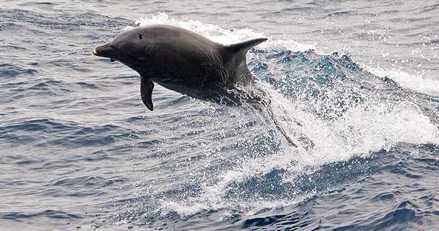
In News: For the first time, avian flu is seen in cetaceans.
More on the Topic:
- This version of the virus, which has spread widely among North American and European birds, has affected an unusually broad array of species.
- It includes two documented cases in cetaceans, a group of marine mammals that includes dolphins, porpoises and whales.
- While experts emphasise that the risk to humans remains low, the spread of the virus to new species poses potential risks to wildlife and provides the virus with new chances to mutate and adapt to mammalian hosts.
- Besides birds, the virus has earlier turned up in foxes, bobcats, skunks, and seals.
About Avian Flu:
- A disease caused by avian influenza (AI) Type A viruses found naturally in wild birds worldwide.
- AI viruses are broadly classified as low pathogenic AI (LPAI) and highly pathogenic AI (HPAI) viruses, based on their pathogenicity. H5N1 strains come under HPAI viruses.
- The virus can infect domestic poultry including chickens, ducks, turkeys and there have been reports of H5N1 infection among pigs, cats, and even tigers in Thailand zoos.
Source: Down To Earth
________________________________________________________________________________

6. Solar Storm
Topic: Science and Technology
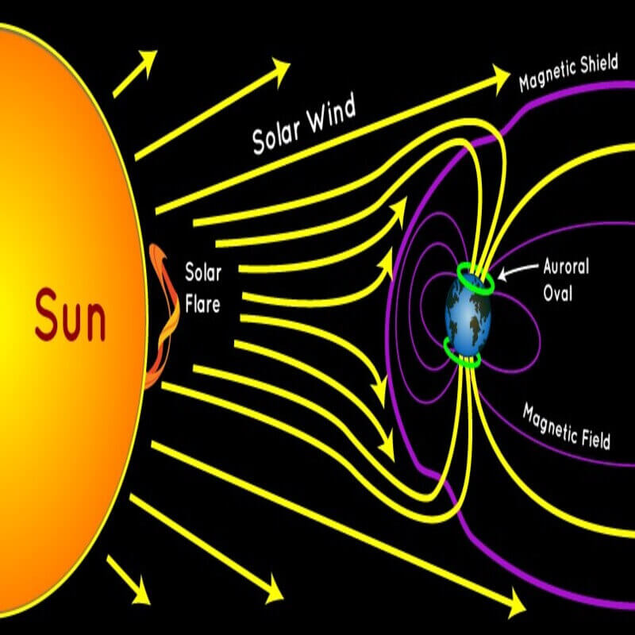
In News: An enormous coronal mass ejection (CME) was recorded exploding on the far side of the Sun, sending a solar storm out across the Solar System.
More on the Topic:
- Geomagnetic storms/solar storms are major disturbance of Earth's magnetosphere.
- Magneto sphere is the area around planet controlled by its magnetic field.
- It occurs when there is a very efficient exchange of energy from solar wind into space environment surrounding Earth.
- The impacts of Solar storm on earth include Disruption of navigation systems such as Global Navigation Satellite System (GNSS) and create harmful geomagnetic induced currents (GICs) in power grid and pipelines.
Source: Business Standard

7. The Zero Emission Vehicles Transition Council
Topic: International Affairs
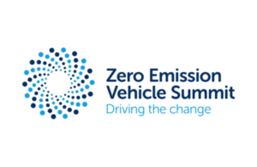
In News: At COP26, India, represented by NITI Aayog, participated in the fourth ministerial dialogue of the ZEVTC.
More on the Topic:
- The Zero Emission Vehicles Transition Council was formed in November 2020.
- It is the world’s first political forum through which ministers and representatives from governments and most progressive automotive markets meet to discuss how to accelerate the pace of the global transition to zero emission vehicles.
Source: Business Standard

